2024 Wisconsin FFA Alumni & Supporters Convention
First Time Attendee Agriculture Educator Scholarship
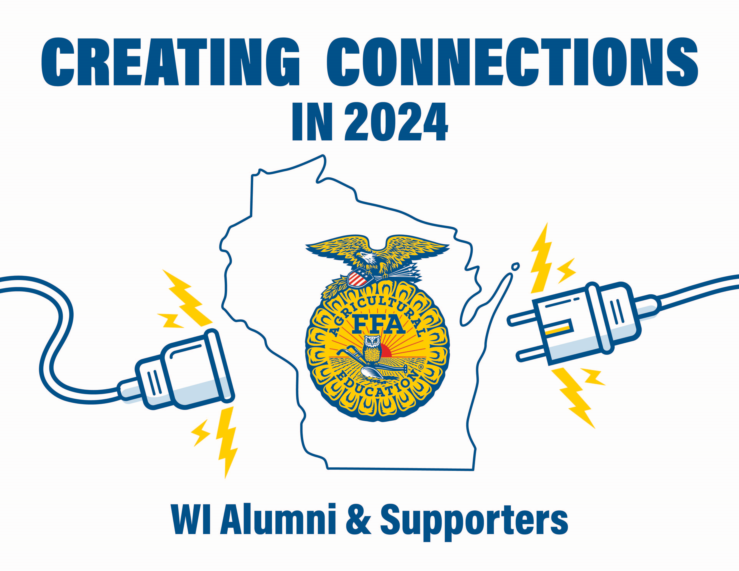
Due December 1st, 2023
Thank You to the Legacy Grant supported by Tractor Supply Company and Give Back to Your Roots Grants supported by Nutrien Ag Solutions, we can offer this scholarship which will help cover/reimburse convention expenses.
Requirements for Scholarship:
- Member of local Alumni Chapter
- Attending the Annual Convention for the first time as a New Agriculture Education Teacher or Agriculture Education Student, junior or Senior year of college.
- Register yourself for convention by the deadline, and reserve your own hotel room
- Actively participate in convention activities
- Write a summary paragraph about your experiences at the 2024 Convention for the spring newsletter OR record your testimonial with the PR Committee prior to leaving the convention. This will be your receipt for the payment of scholarship.
- Completed scholarship should be emailed to Cari Sabel: musicalaggal@gmail.com
Please fill in the following information to the best of your ability.
Applicant Name:
Address:
Phone Number:
Email:
Local FFA Alumni & Supporters Chapter:
Questions to be answered by the applicant. You may add space up to two pages if necessary. Question 3 and 4 are part of the summary response or testimonial.
- List all activities you are currently involved in with your local FFA Alumni and Supporters Chapter.
- What school are you teaching at or student teaching at?
- How will you take the information you learn at the convention and bring it back to your local chapter?
- What did you like most and least about the convention? This will be in your summary response.

